**Getting Started**

* **Step 1:** Download or clone the [starter repo here](https://github.com/udacity/nd698-c2-systems-security-project-starter).
* **Step 2:** Download a copy of the [ubuntu.ova file from AWS](https://udacity-send.s3-us-west-2.amazonaws.com/2021_analysis_image_final.ova" \t "_blank). Don't be concerned if it takes some time to download. If 30 minutes pass and the file has not downloaded, cancel and reattempt the download. If it's still not successful, please reach out to Udacity staff. *(This OVA file is updated as of April 2021)*
* **Step 3:** Download & install [Oracle Virtualbox 6.1.xx](https://www.virtualbox.org/wiki/Downloads) software which will be used as our virtualization tool for loading the OVA file downloaded above. Refer to these [instructions](https://www.virtualbox.org/manual/ch02.html) on how to install Virtualbox on your respective local host OS.
  + Note that the Mac M1 chips do not support Virtualbox as of Dec 2021. See this list of the [supporting host OSes](https://www.virtualbox.org/manual/ch01.html#hostossupport).
  + For configuring the VirtualBox, you must enable the hardware virtualization on the host machine. These threads may help:
    - [How to enable support of CPU virtualization on Macbook?](https://stackoverflow.com/questions/13580491/how-to-enable-support-of-cpu-virtualization-on-macbook-pro)
    - [Enabling Virtualization in your Windows PC BIOS](https://bce.berkeley.edu/enabling-virtualization-in-your-pc-bios.html)
* **Step 4:** Download and Install Docker Desktop from its official website. Depending on your operating system, you can follow one of the below links to download and set up docker on your computer.
  + [Windows](https://docs.docker.com/docker-for-windows/install/)
  + [MacOS](https://docs.docker.com/docker-for-mac/)
  + [Linux](https://docs.docker.com/engine/install/ubuntu/)

In this project, you will use Docker to run the GVM tool. Alternatively, you can run the GVM as a VM in the Virtualbox.

**Installation**

As soon as the Virtualbbox tool starts, ensure that the **Virtualbox >> File >> Host Network Manager** has a host-only network available.

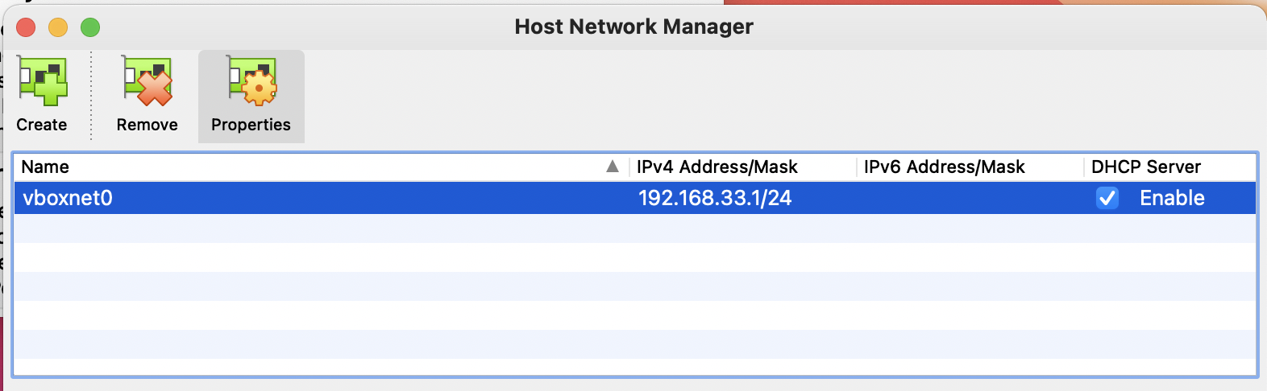

Verifying the *Virtualbox >> File >> Host Network Manager* settings

* **Step 1: Load the OVA file** - Double click or right-click on the OVA file to load it in Virtualbox. You will be presented with an Appliance settings page which will reflect the virtual machine’s settings and configuration. Click on Import to begin creating the virtual machine on your computer.

Allow the installation to complete. It will take a few minutes before the virtual machine is up and running.

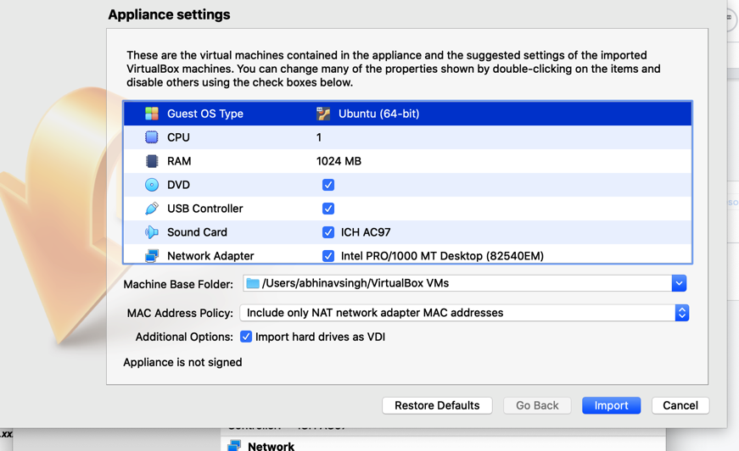

No Need to Change the Settings! Just Click "Import"

* **Step 2: Configure the VM Network Settings** - Your VirtualBox Manager will now be reflecting the virtual machine. Go to VM's **Settings >> Network** tab. Make sure to choose the following adapters:
  + **Adapter 1** - Choose NAT. This is useful if you want to access the server running on a **specific** port in the VM from the host browser. Choosing NAT requires you to do the port forwarding. NAT also allows your VM to access the outside Internet.
  + **Adapter 2** - Choose Host-only. This will allow VM to VM communication. This will allocate your VM an IP from the DHCP (virtual) network.
  + **Adapter 3** - Choose Bridged. This will allow you access the VM from the host. In addition, this mode also supports VM to VM communication. This is particularly useful is you'd have to scan the current VM from another VM (GVM VM).

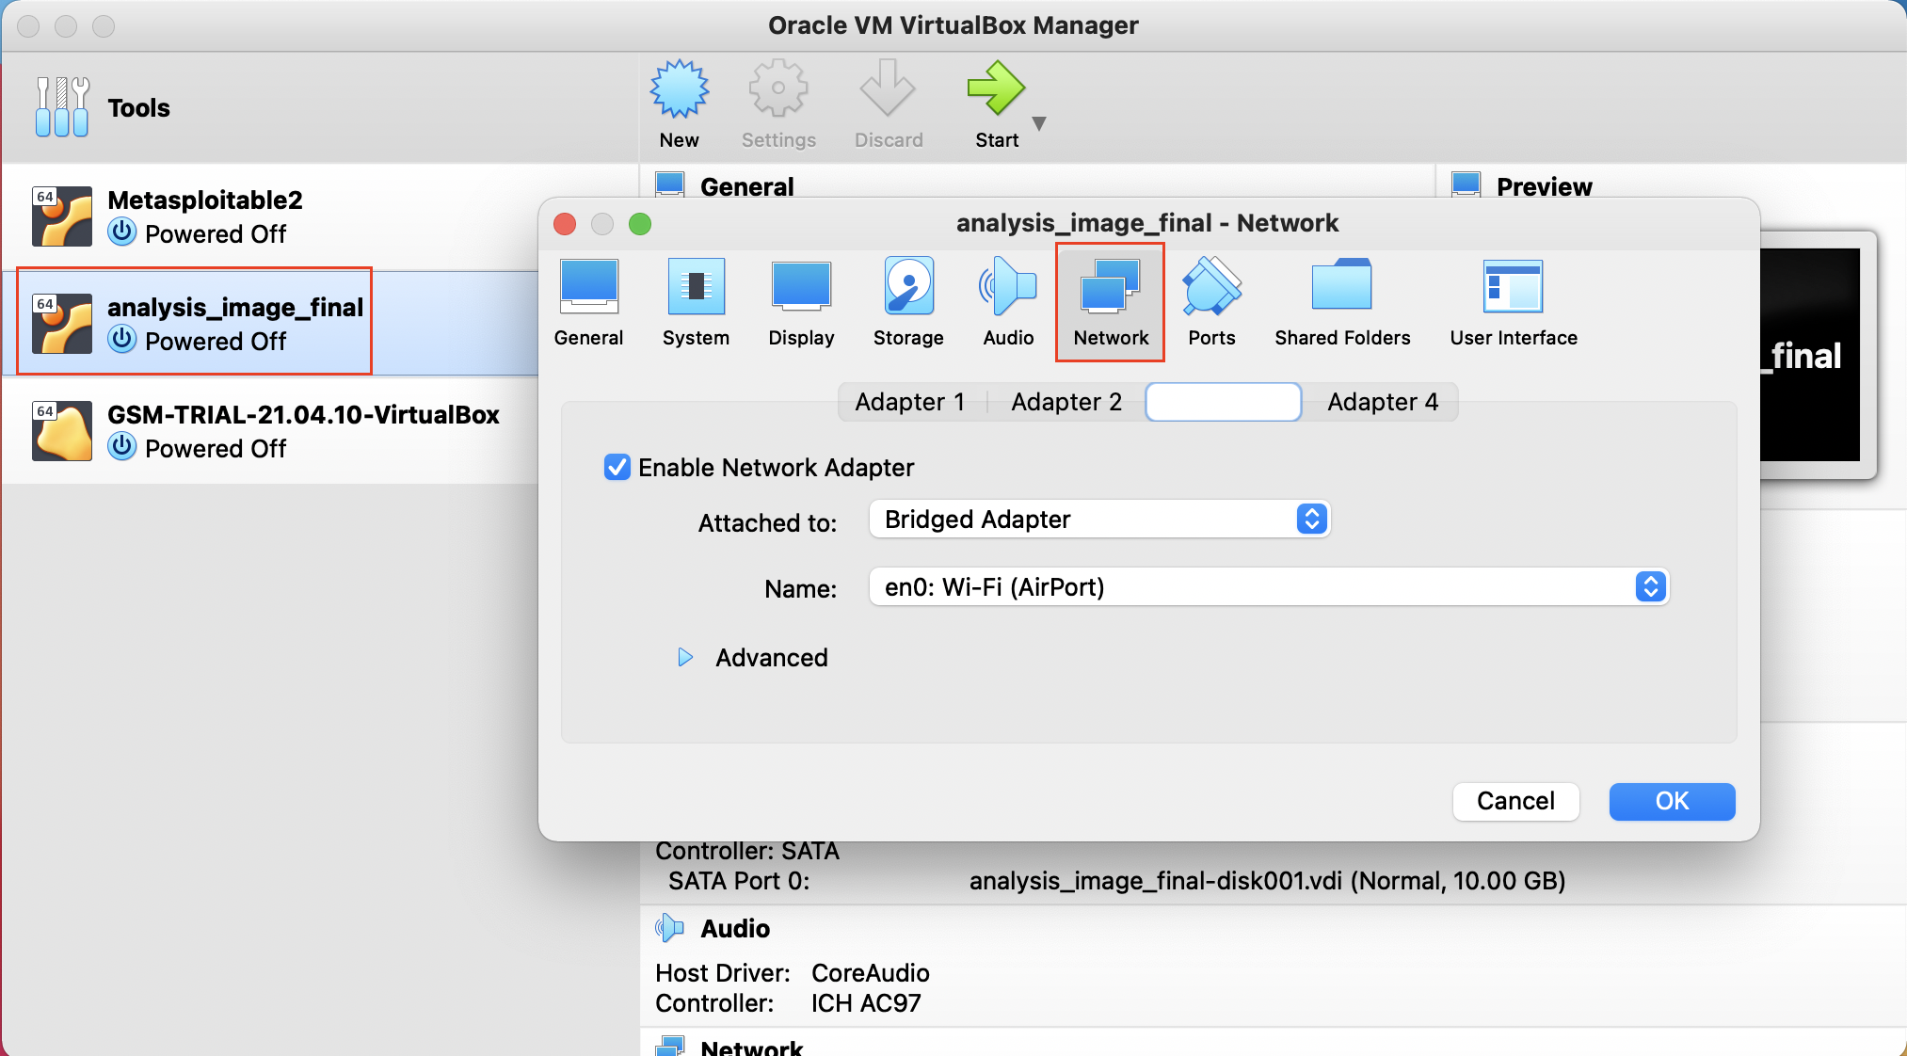

Ensure to choose all three Adapters carefully.

* **Step 3: Start the VM** - You are now ready to launch the virtual machine. Click on "Start" to begin loading the Ubuntu OS as your virtual machine.
* **Step 4: Login** Keep a note of the default username and password of the ubuntu linux which is already created for you.
* Username: ubuntu
* Password: ubuntu
* **Step 5: Find the IP address** Once the Desktop is loaded, open the terminal in Ubuntu and run the command ifconfig to list the available interfaces and their IP addresses. Note the IP address associated with eth1. It should be in the form of 192.168.xxx.xxx.

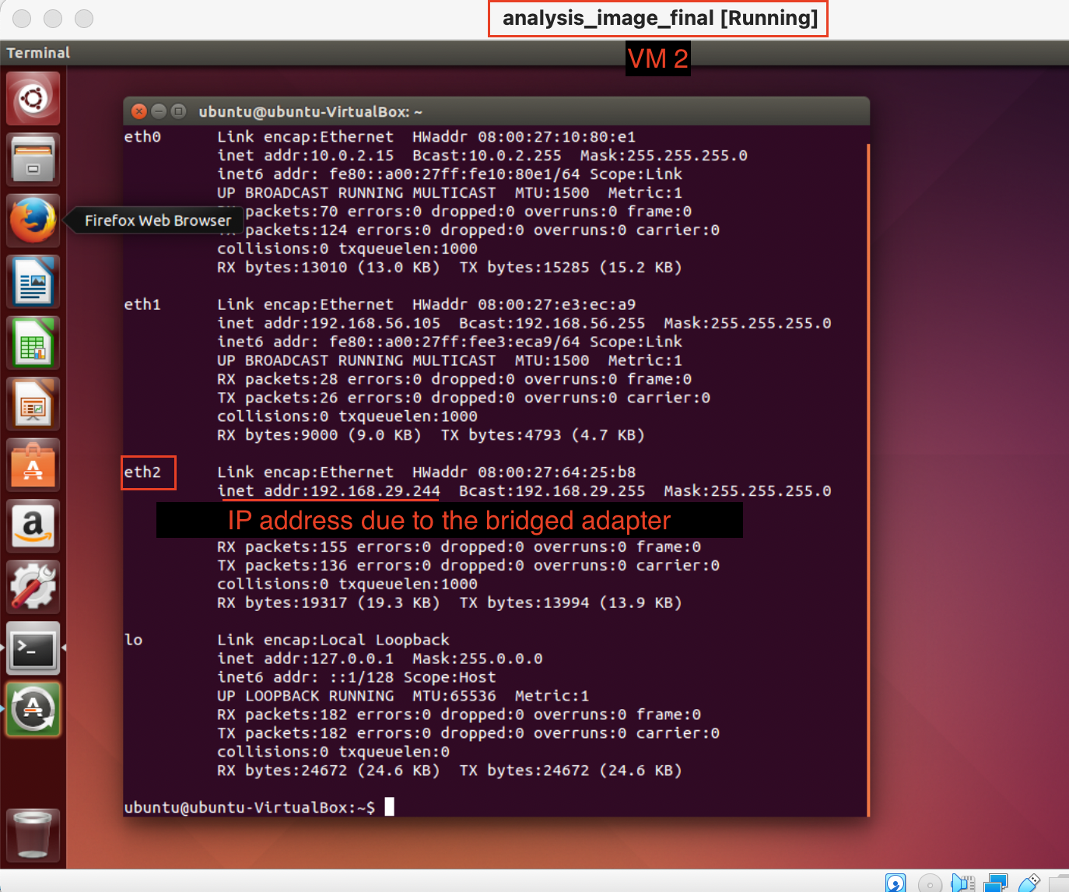

Finding the IP address

**Testing**

* **Step 1:** Open the terminal in Ubuntu VM and run the command ifconfig to list the available interfaces and their IP addresses.
* **Step 2:** Note the IP address associated with eth1. It should be in the form of 192.168.xxx.xxx.
* **Step 3:** Come back to your host operating system and launch the command prompt or terminal. Run the command:
* ping 192.168.xxx.xxx

If the packets are successfully getting delivered, it means that your guest operating system (virtual machine) is accessible from the host operating system.

**Troubleshoot**

* **VM Aborts abruptly**: If the VM aborts shortly after startup, try starting VirtualBox using the terminal: If that doesn't work, try these steps:
  + Go to **File** > **Import Appliance** > **Expert Mode** >. Uncheck box for **Import hard drives as VDI**
  + Import Security Onion OVA
  + Right-click VM in the manager. Go to **Settings** > **Display** > **Screen** > **Increase the Video Memory**
* **USB 2.0 Controller Not Found** error

This error can be removed by navigating into OVA file's settings in Virtualbox. Inside the *Settings* tab, select the *Ports* tab and disable the check mark against *Enable USB controller*. This will remove the USB controller from the image. Save it and restart the virtual machine.

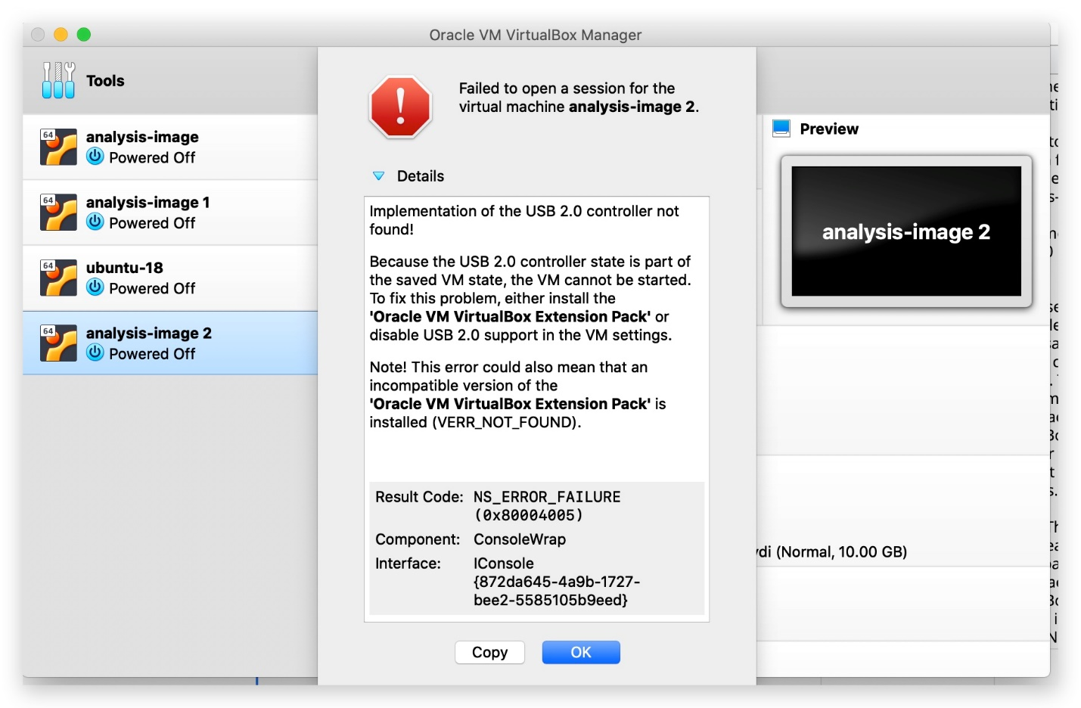

**USB 2.0 Controller Error**

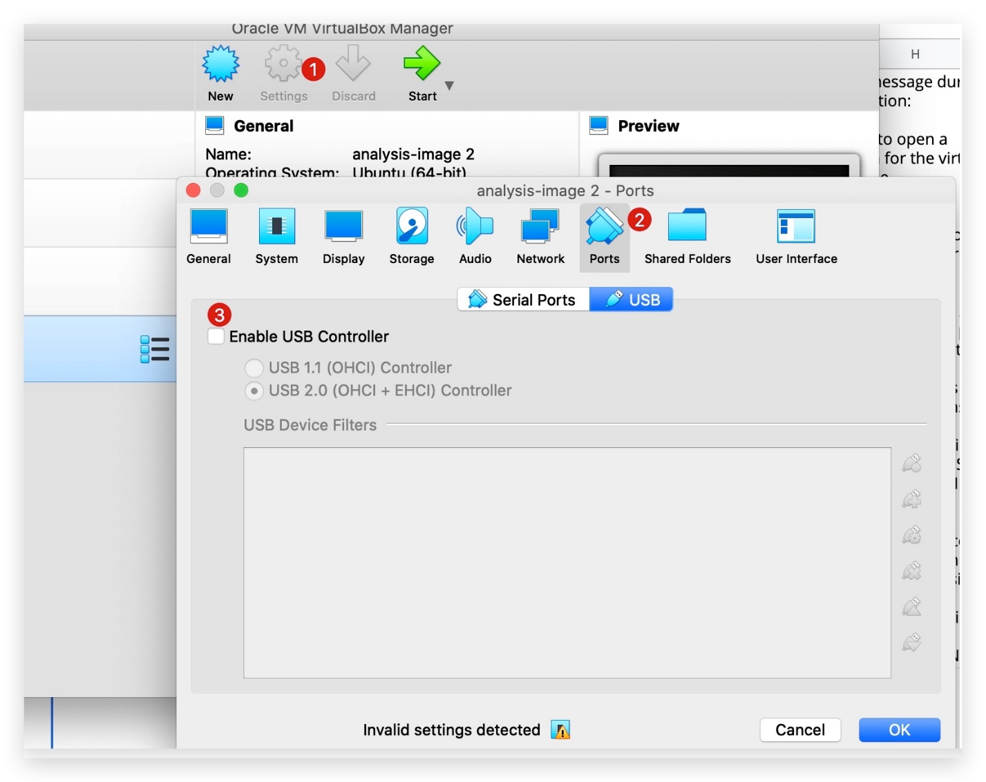

Settings to Remove the USB 2.0 Controller Error

* *How do I ensure I have the right OVA file downloaded?*  
  It's easy to check the ND5 checksum of the downloaded file.
* *# Feel free to change the filename, as applicable to you*
* md5 2021\_analysis\_image\_final.ova

The expected output should be **exactly same** as shown in the snapshot below.

